Module III: Memory Systems & Cache Organization

Memory Hierarchy
- A memory hierarchy organizes computer storage into ranked levels based on speed, cost, and capacity to optimize overall system performance.
- In the Computer System Design, Memory Hierarchy is an enhancement to organize the memory such that it can minimize the access time. The Memory Hierarchy was developed based on a program behaviour known as locality of references.
Memory Hierarchy helps in optimizing the memory available in the computer. There are multiple levels present in the memory, each one having a different size, different cost, etc. Some types of memory like cache, and main memory are faster as compared to other types of memory but they are having a little less size and are also costly whereas some memory has a little higher storage value, but they are a little slower. Accessing of data is not similar in all types of memory, some have faster access whereas some have slower access.

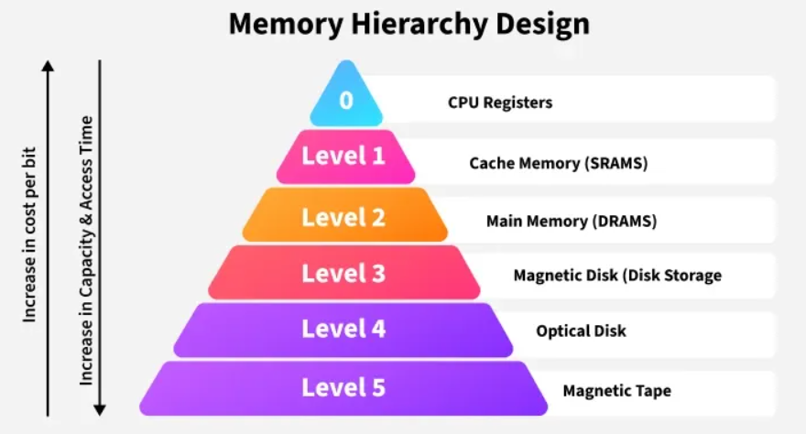

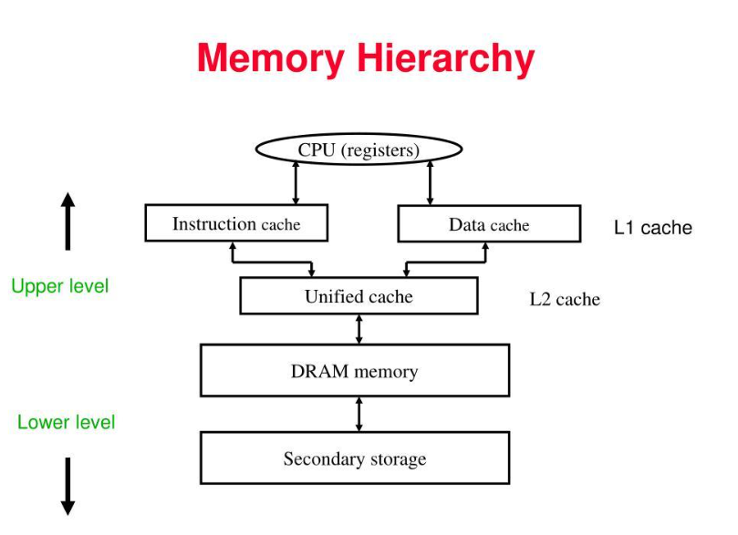
Memory Hierarchy Design
1. Registers
Registers are small, high-speed memory units located in the CPU. They are used to store the most frequently used data and instructions. Registers have the fastest access time and the smallest storage capacity, typically ranging from 16 to 64 bits.

2. Cache Memory
Cache memory is a small, fast memory unit located close to the CPU. It stores frequently used data and instructions that have been recently accessed from the main memory. Cache memory is designed to minimize the time it takes to access data by providing the CPU with quick access to frequently used data.

3. Main Memory
Main memory, also known as RAM (Random Access Memory), is the primary memory of a computer system. It has a larger storage capacity than cache memory, but it is slower. Main memory is used to store data and instructions that are currently in use by the CPU.

Types of Main Memory
Static RAM: Static RAM stores the binary information in flip flops and information remains valid until power is supplied. Static RAM has a faster access time and is used in implementing cache memory.
Dynamic RAM: It stores the binary information as a charge on the capacitor. It requires refreshing circuitry to maintain the charge on the capacitors after a few milliseconds. It contains more memory cells per unit area as compared to SRAM.
read more about - Different Types of RAM (Random Access Memory)

4. Secondary Storage
Secondary storage, such as hard disk drives (HDD) and solid-state drives (SSD) , is a non-volatile memory unit that has a larger storage capacity than main memory. It is used to store data and instructions that are not currently in use by the CPU. Secondary storage has the slowest access time and is typically the least expensive type of memory in the memory hierarchy.

5. Magnetic Disk
Magnetic Disks are simply circular plates that are fabricated with either a metal or a plastic or a magnetized material. The Magnetic disks work at a high speed inside the computer and these are frequently used.

6. Magnetic Tape
Magnetic Tape is simply a magnetic recording device that is covered with a plastic film. Magnetic Tape is generally used for the backup of data. In the case of a magnetic tape, the access time for a computer is a little slower and therefore, it requires some amount of time for accessing the strip.

Characteristics of Memory Hierarchy
- Capacity: It is the global volume of information the memory can store. As we move from top to bottom in the Hierarchy, the capacity increases.
- Access Time: It is the time interval between the read/write request and the availability of the data. As we move from top to bottom in the Hierarchy, the access time increases.
- Performance: The Memory Hierarch design ensures that frequently accessed data is stored in faster memory to improve system performance.
- Cost Per Bit: As we move from bottom to top in the Hierarchy, the cost per bit increases i.e. Internal Memory is costlier than External Memory.

Advantages of Memory Hierarchy
- Performance: Frequently used data is stored in faster memory (like cache), reducing access time and improving overall system performance.
- Cost Efficiency: By combining small, fast memory (like registers and cache) with larger, slower memory (like RAM and HDD), the system achieves a balance between cost and performance. It saves the consumer's price and time.
- Optimized Resource Utilization: Combines the benefits of small, fast memory and large, cost-effective storage to maximize system performance.
- Efficient Data Management: Frequently accessed data is kept closer to the CPU, while less frequently used data is stored in larger, slower memory, ensuring efficient data handling.
Disadvantages of Memory Hierarchy
- Complex Design: Managing and coordinating data across different levels of the hierarchy adds complexity to the system's design and operation.
- Cost: Faster memory components like registers and cache are expensive, limiting their size and increasing the overall cost of the system.
- Latency: Accessing data stored in slower memory (like secondary or tertiary storage) increases the latency and reduces system performance.
- Maintenance Overhead: Managing and maintaining different types of memory adds overhead in terms of hardware and software.

Why do we need Memory Hierarchy?
The memory hierarchy is needed for the following reasons:
1. To increase processing speed: The CPU operates very fast, but main memory (RAM) is comparatively slower. Faster memory, such as cache, reduces this speed gap.
2. To reduce memory access time: Frequently used instructions and data are stored in faster memory so that the CPU can access them quickly.
3. To reduce overall cost: Very fast memory is expensive. A hierarchy combines a small amount of expensive memory with a large amount of affordable memory.
4. To provide large storage capacity: Secondary storage devices, such as SSDs and HDDs, store large amounts of data permanently.
5. To improve CPU performance: The CPU spends less time waiting for data, allowing programs to execute more efficiently.
Levels of Memory
Level 1: Registers
Level 2: Cache Memory
Level 3: Main Memory
Level 4: Secondary Memory
Level 5: Tertiary or Offline Storage
Feature | Registers | Cache | RAM | SSD/HDD
Speed | Highest | Very high | Moderate | Lower
Capacity | Very small | Small | Larger | Very large
Cost per bit | Highest | High | Moderate | Low
Volatility | Volatile | Volatile | RAM: volatile | Non-volatile
Main purpose | Immediate CPU operations | Fast data access | Active programs | Long-term storage

Memory Performance
Memory performance refers to how efficiently a computer system stores, retrieves, and transfers data between the processor (CPU), cache memory, RAM, and other storage components.
When a CPU executes a program, it frequently requests data and instructions from memory. The speed and efficiency of these operations affect the overall performance of the computer.
The three major measures of memory performance are:
- Latency — the time required to access data.
- Throughput — the amount of work or number of operations completed per unit of time.
- Bandwidth — the amount of data transferred per unit of time.

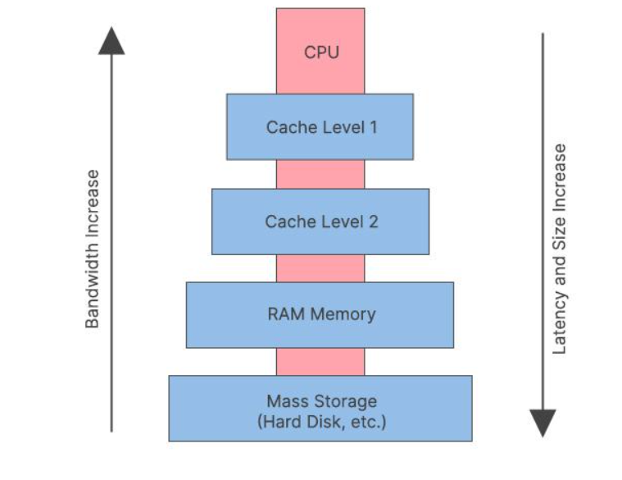
Latency

Definition
Memory latency is the time delay between making a memory request and receiving the requested data.
It indicates how quickly a memory system responds to a request from the processor. Lower latency generally results in faster responses.

How memory latency works
Consider a situation in which the CPU needs to read a value stored in RAM. The time taken for this process contributes to memory access latency.
Step 3: Data becomes available
Step 2: Memory processes the request
Step 1: CPU requests data

Figure: memory latency works

Types of latency
- Memory access latency: Time required to access a requested memory location.
- Read latency: Time associated with obtaining data from memory after a read request.
- Write latency: Time associated with completing a write operation, depending on how completion is defined.
- Cache latency: Time required to access data in cache memory, which is generally much lower than accessing DRAM.

Factors affecting latency
- Memory technology: SRAM, DRAM, and storage devices have different response characteristics.
- Memory hierarchy: Cache memory is generally faster to access than main memory.
- Memory controller: Its scheduling and request-handling decisions can affect delays.
- Memory access pattern: Random accesses can have more delay than sequential accesses.
- Contention: Multiple processors or cores competing for memory resources can increase waiting time.
- Row activation and precharging: DRAM may require additional internal operations before accessing data.

Formula
A simplified expression for latency is:
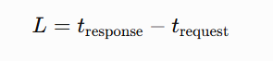
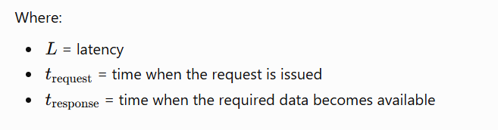

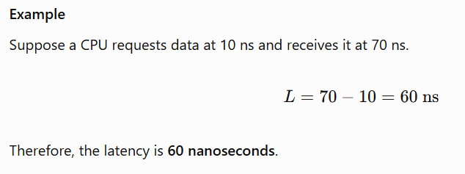

Importance of latency
- Improves the response time of applications.
- Helps performance in tasks with frequent, dependent memory accesses.
- Is important for databases, gaming, real-time systems, and interactive applications.
- Reduces the time the CPU may spend waiting for data.
Throughput

Definition
Throughput is the amount of useful work or the number of operations completed by a memory system per unit of time.
It describes how effectively the memory system handles memory requests or data operations over time.
Throughput depends on factors such as the number of requests being processed, memory-level parallelism, available memory resources, and workload characteristics.

How throughput works
Imagine a memory system receiving several requests from different CPU cores.
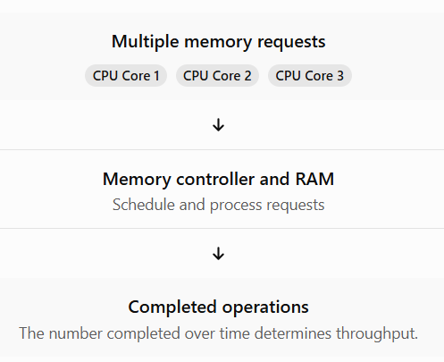
A system that can process more independent requests concurrently may achieve higher throughput, even if the latency of an individual request remains unchanged.
Steps
1. Multiple Memory Requests: Different CPU cores (Core 1, Core 2, and Core 3) generate memory requests simultaneously.
2. Memory Controller Receives Requests: The memory controller receives requests from the CPU cores.
3. Scheduling of Requests: The memory controller schedules the requests in an appropriate order to avoid conflicts and manage access to RAM.
4. Processing Requests: RAM processes the scheduled memory read and write requests.
5. Completion of Operations: The requested memory operations are completed, and the required data is transferred.
6. Throughput Measurement: The number of memory operations completed per unit of time determines the memory throughput.

Types of throughput
- Memory operation throughput: Number of read/write operations completed per second.
- Request throughput: Number of memory requests handled per second.
- Data throughput: Amount of data successfully processed or transferred per second. This overlaps with bandwidth, depending on the measurement.
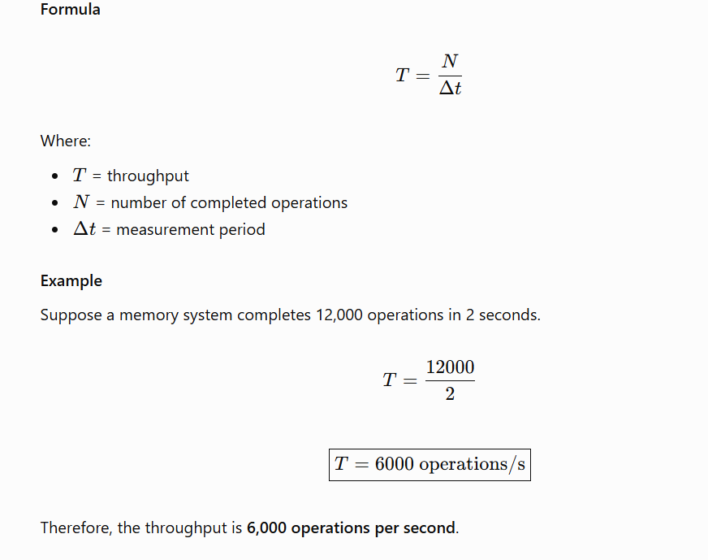

Factors affecting throughput
- Number of CPU cores: More cores can generate more memory requests.
- Parallelism: Independent requests can be processed concurrently.
- Memory channels: Multiple channels can increase the amount of work handled.
- Request size: Different request sizes affect the number of operations and total data processed.
- Memory controller efficiency: Better scheduling can improve resource utilization.
- Contention: Too many competing requests can reduce the rate of useful work.
- Workload type: Sequential, random, read-heavy, and write-heavy workloads can have different throughput.

Importance of throughput
- Helps evaluate memory performance under multiple simultaneous requests.
- Is important for servers and database systems.
- Supports efficient processing in multicore computers.
- Helps assess the performance of workloads with many concurrent memory operations.
Bandwidth

Definition
Memory bandwidth is the amount of data transferred between memory and another component, such as the CPU, per unit of time.
It measures the data transfer capacity of a memory system. Bandwidth can refer to theoretical maximum bandwidth or the bandwidth actually achieved by an application.

How bandwidth works
Consider RAM transferring data to the CPU through a memory channel. If the channel transfers more bytes every second, it provides greater bandwidth.
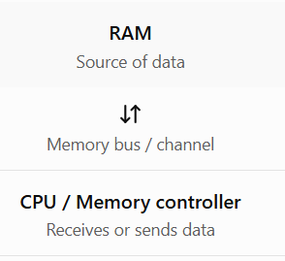
Step 1: RAM (Random Access Memory)
- RAM stores the data and instructions required by the CPU.
- It acts as a temporary working memory of the computer.
- It supplies data when the CPU needs it.
Step 2: Memory Bus / Channel
- The memory bus is the communication pathway between RAM and the CPU/memory controller.
- It carries data in both directions, as shown by the two-way arrow (↕).
- Data can travel from RAM to the CPU and from the CPU to RAM.
Step 3: CPU / Memory Controller
- The CPU processes instructions and performs calculations.
- The memory controller manages communication between the CPU and RAM.
- It receives data from RAM and sends data to RAM when required.

Types of bandwidth
- Theoretical bandwidth: Maximum transfer rate estimated from memory speed and bus width.
- Sustained bandwidth: Average transfer rate maintained over a longer period.
- Achieved bandwidth: Actual data transfer rate measured for a particular workload.
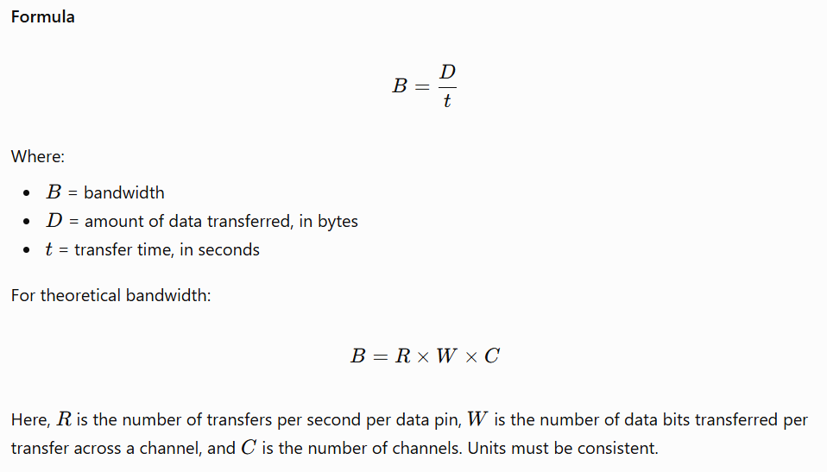
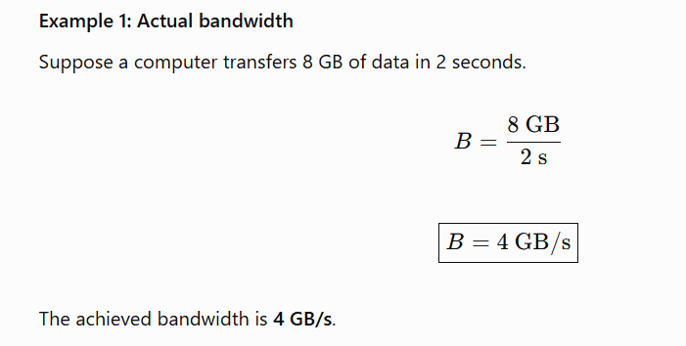
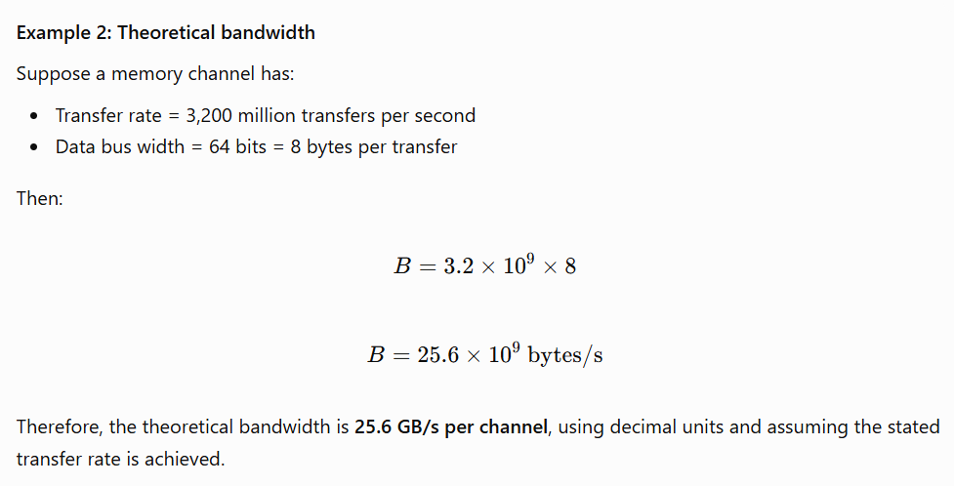

Factors affecting bandwidth
- Memory transfer rate: Faster memory can transfer more data per second.
- Bus width: A wider data bus can carry more bits per transfer.
- Number of memory channels: More channels can increase aggregate bandwidth.
- Memory access pattern: Sequential access often makes better use of bandwidth than scattered access.
- CPU and memory-controller limits: The processor platform can restrict achievable bandwidth.
- Competing requests: Multiple cores may share the available bandwidth.
- Read/write mix: Workload direction and memory-controller scheduling can affect actual bandwidth.

Importance of bandwidth
- Supports large data transfers.
- Improves performance in scientific computing and data analytics.
- Is important for integrated graphics and GPUs.
- Helps in video processing, simulations, and large-scale machine learning.
- Reduces transfer bottlenecks when applications need substantial data movement.

Detailed comparison
Parameter | Latency | Throughput | Bandwidth
Main purpose | Measures delay | Measures completed work | Measures data transfer rate
Typical unit | ns | Operations/s | GB/s
Desired performance | Lower | Higher | Higher
Main question | How long does one request take? | How many operations finish per second? | How many bytes move per second?
Example | 60 ns | 6,000 operations/s | 25.6 GB/s
Important for | Dependent memory accesses | Concurrent requests | Large data transfers

Introduction to Memory Technologies
Memory technology refers to the electronic methods and devices used to store data, instructions, and information in a computer system. Memory is an essential component because the CPU requires fast access to program instructions and data to perform calculations and execute applications.
Different memory technologies are designed to meet different requirements, such as speed, storage capacity, cost, power consumption, and data retention.
The major memory technologies include:
- SRAM (Static Random Access Memory)
- DRAM (Dynamic Random Access Memory)
- SDRAM (Synchronous Dynamic Random Access Memory)
- DDR SDRAM (Double Data Rate Synchronous Dynamic Random Access Memory)
- ROM (Read-Only Memory)
- Flash Memory
SRAM and DRAM are the two major types of RAM used in computer memory systems. SDRAM and DDR are forms of DRAM designed to improve synchronization and data transfer performance.
Memory hierarchy diagram
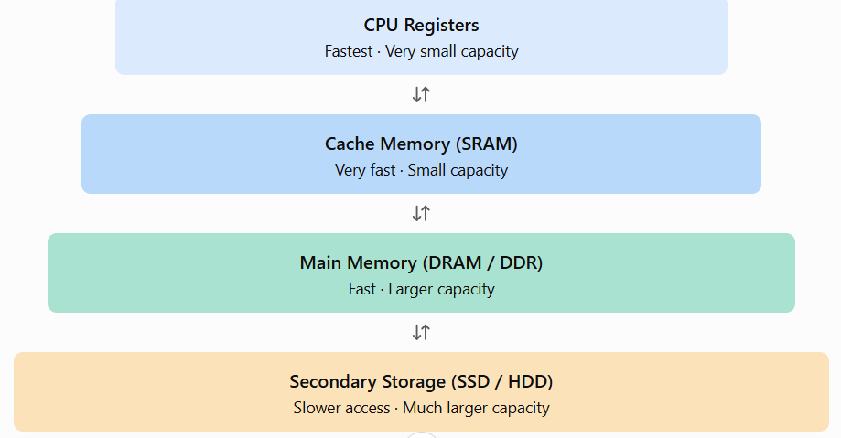
Static Random Access Memory (SRAM)
SRAM is a type of volatile semiconductor memory that stores each bit using a bistable circuit, commonly implemented with six transistors in a standard SRAM cell.
It is called static because the stored bit does not need periodic refreshing as long as power is supplied.

Basic SRAM cell diagram
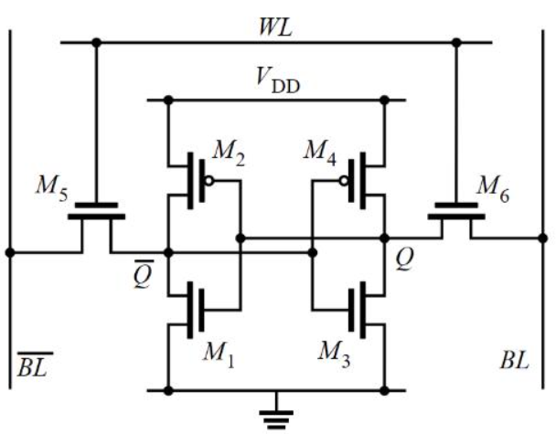
A typical SRAM cell contains:
- Two cross-coupled inverters that hold a logical 0 or 1.
- Two access transistors that connect the cell to bit lines.
- A word line that controls access to the cell.

Working principle
- Write operation: The required bit is placed on the bit lines, and the word line activates the access transistors.
- Read operation: The word line is activated, and the stored value affects the bit-line signals.
- Data retention: The feedback circuit maintains the bit while the power supply is present.

Characteristics of SRAM
- Very fast access compared with conventional DRAM.
- Does not require periodic refresh.
- Volatile: data is lost when power is removed.
- Requires more transistors per bit, making it relatively expensive.
- Has lower storage density than DRAM.

Applications
- CPU L1, L2, and L3 caches.
- Small high-speed buffers.
- Network devices and embedded systems.
- Specialized high-speed memory circuits.

Advantages
- Low access latency.
- No refresh operations.
- Good for frequently accessed data.

Disadvantages
- High cost per bit.
- Larger chip area per stored bit.
- Lower capacity for a given chip area compared with DRAM.
Example: A CPU cache commonly uses SRAM because the processor needs very fast access to frequently used instructions and data.

Dynamic Random Access Memory (DRAM)
DRAM is a type of volatile semiconductor memory that stores each bit of information as an electrical charge in a capacitor. It is called dynamic because the stored charge gradually leaks away and must be refreshed periodically.
DRAM is widely used as the main memory (RAM) in desktop computers, laptops, and servers.
Basic DRAM cell diagram
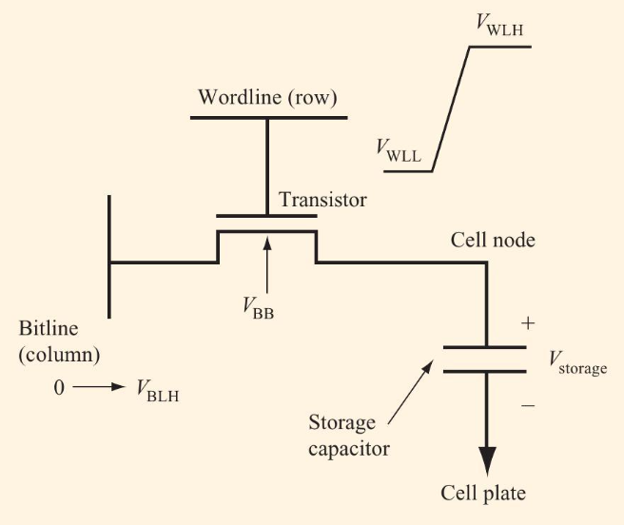
A basic DRAM cell contains two main components:
- Capacitor: Stores the electrical charge representing a bit.
- Transistor: Controls access to the capacitor during read and write operations.

Working principle
- Write: The capacitor is charged or discharged to represent a binary value.
- Read: The circuit senses the capacitor's charge through the bit line.
- Refresh: The stored information is restored periodically because the capacitor loses charge over time.
Reading a DRAM cell is effectively destructive to its stored charge, so the sensed value must be restored as part of the read process.

Characteristics of DRAM
- Volatile memory.
- Requires periodic refreshing.
- Higher storage density than SRAM.
- Lower cost per bit than SRAM.
- Generally slower access than SRAM.
- Available in large capacities.

Applications
- Main memory in personal computers.
- Servers and workstations.
- Gaming computers.
- Graphics memory, in specialized forms such as GDDR.
- Mobile devices, using low-power DRAM such as LPDDR.

Advantages
- High storage density.
- Lower cost per bit.
- Suitable for large-capacity memory.
- Good balance between performance and cost.

Disadvantages
- Requires refresh operations.
- Higher access latency than SRAM.
- Refreshing consumes power.
- Data is lost when power is removed.
Example: A computer with 16 GB of RAM generally uses DRAM-based technology for its main memory.
Synchronous DRAM (SDRAM)
SDRAM stands for Synchronous Dynamic Random Access Memory. It is a type of DRAM that synchronizes its operations with a clock signal.
Traditional asynchronous DRAM does not use the system clock in the same way to coordinate memory commands. SDRAM uses clocked commands and organized data transfers to improve performance.

Working principle
- The memory controller issues commands in coordination with the clock.
- SDRAM selects the required bank and activates a row.
- The desired column is accessed.
- Data is transferred according to the memory's timing rules.
SDRAM supports burst transfers, which allow multiple data values to be transferred after an initial access.

Advantages
- Predictable, clock-coordinated operation.
- Supports burst data transfers.
- Better performance than older asynchronous DRAM designs.
- Forms the basis of modern DDR memory technologies.

Applications
SDRAM technology is used in computer main memory, embedded systems, and other electronic devices. Modern DDR memory is an advanced form of synchronous DRAM.
DDR SDRAM and its generations
DDR stands for Double Data Rate Synchronous Dynamic Random Access Memory.
DDR transfers data on both the rising and falling edges of the memory clock, allowing two transfers per clock cycle per data pin.
This improves the data transfer rate without requiring the clock itself to run at twice the frequency of an equivalent single-data-rate interface.
DDR working diagram
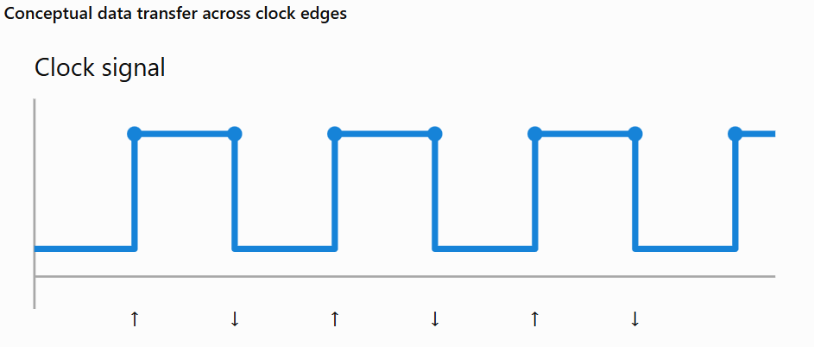

Major DDR generations
Generation | Main improvement
DDR | First generation of double-data-rate SDRAM
DDR2 | Higher data rates and reduced I/O voltage compared with DDR
DDR3 | Higher transfer rates and improved power efficiency
DDR4 | Higher density and transfer rates, with lower operating voltage than DDR3
DDR5 | Higher bandwidth, greater potential capacity, and improved power-management architecture
The exact speed depends on the memory module and platform. These generations are generally not interchangeable because they have different electrical requirements, signaling, and module designs.

Applications
- Desktop computers and laptops.
- Servers and cloud computing systems.
- High-performance workstations.
- Scientific computing.
- Gaming and content creation.
Important: DDR4 and DDR5 are not separate fundamental memory-cell technologies like SRAM versus DRAM. Both are generations of synchronous DRAM.

Read-Only Memory (ROM)
ROM is a category of non-volatile memory that retains information without continuous power. It is used to store instructions or data that must remain available after a computer is switched off.
Unlike ordinary RAM, ROM is not primarily intended for frequent, unrestricted read-and-write operations.

Types of ROM
1. Mask ROM
- Programmed during manufacturing.
- Contents are not normally changeable.
- Suitable for high-volume products requiring fixed data.
2. PROM (Programmable ROM)
- Initially supplied in an unprogrammed state.
- Programmed once by the user or manufacturer.
- Usually cannot be erased and reprogrammed.
3. EPROM (Erasable Programmable ROM)
- Can be erased using ultraviolet light in traditional EPROM devices.
- Can then be programmed again.
- Often requires removing the chip from its circuit.
4. EEPROM (Electrically Erasable Programmable ROM)
- Can be erased and programmed electrically.
- Supports updating selected data without erasing the entire chip in many implementations.
- Used for small configuration values and settings.

Applications
- Firmware storage.
- Embedded systems.
- Device configuration.
- Microcontroller programs.
- Hardware initialization instructions.

Advantages
- Retains data without power.
- Suitable for permanent or semi-permanent instructions.
- Reliable for storing firmware.

Disadvantages
- Some forms are difficult or slow to modify.
- Write endurance can be limited for programmable forms.
- Conventional ROM is not designed to replace high-speed working RAM.

Flash Memory

Definition
Flash memory is a type of non-volatile semiconductor memory that stores information using charge-storage structures in memory cells. It can be electrically erased and programmed.
It is widely used in USB drives, memory cards, SSDs, and smartphones.

Types of flash memory
- NAND flash: Optimized for dense data storage; commonly used in SSDs, USB drives, and memory cards.
- NOR flash: Provides convenient random reads and is commonly used for firmware and code storage.

Working principle
- Data is programmed by changing the electrical state of the memory cells.
- The memory controller reads cell states to determine the stored information.
- Erasure occurs in blocks or larger units, depending on the design.
- The stored data remains when power is removed.

Advantages
- Non-volatile.
- High storage density.
- No moving mechanical parts.
- Lower access time than mechanical hard drives for many operations.
- Available in compact form factors.

Disadvantages
- Limited program/erase endurance.
- Erasing generally occurs in larger units than reading or programming.
- Performance can decline under certain workloads.
- Requires controllers and management techniques such as wear leveling in many devices.
Important distinction: Flash memory is usually considered storage rather than the computer's primary working RAM, even though both use semiconductor technology.

Comparison of main memory technologies
Feature | SRAM | DRAM / DDR | ROM | Flash
Volatility | Volatile | Volatile | Non-volatile | Non-volatile
Refresh required | No | Yes | No | No
Relative speed | Very high | High, but typically slower than SRAM | Depends on type | Depends on type
Density | Low | High | Varies | Very high
Cost per bit | High | Lower than SRAM | Varies | Generally economical at high capacities
Main use | CPU cache | Main system RAM | Firmware | SSDs and removable storage

Cache Memory:
Cache memory is a small, high-speed memory located inside or close to the CPU that stores frequently or recently used instructions and data. It helps the processor access information faster than retrieving it from main memory (RAM) every time.
Modern processors execute billions of operations per second. However, main memory is slower than the CPU. If the processor had to wait for RAM for every instruction or data request, overall performance would decrease. Cache memory helps reduce this delay.
Cache memory is generally built using SRAM (Static Random Access Memory) because SRAM provides low access latency and does not require periodic refreshing.

Purpose / Need of Cache Memory
The primary purpose of cache memory is to reduce the average time required to access instructions and data, thereby improving CPU performance.

A. Reduces memory access time
Cache memory is faster to access than main memory. When the requested information is available in cache, the CPU can obtain it without waiting for a RAM access.

B. Bridges the speed gap
The CPU can operate much faster than main memory can supply data. Cache reduces the impact of this speed difference.

C. Exploits locality of reference
Cache memory works effectively because programs tend to access the same information repeatedly or access nearby memory locations.
There are two major types of locality:
- Temporal locality: Recently accessed information is likely to be accessed again soon.
- Spatial locality: Information near a recently accessed memory location is likely to be accessed soon.
Example: In a loop that adds the elements of an array, the CPU accesses the loop instructions repeatedly and reads consecutive array elements. Cache can keep the instructions and recently fetched data close to the processor.

D. Reduces CPU waiting time
When instructions and data are available in cache, the processor spends less time waiting for main memory. This can improve overall execution speed.

E. Reduces traffic to main memory
Cache hits can avoid repeated requests to RAM, reducing pressure on the memory system.

F. Improves overall system performance
Cache is particularly useful in operating systems, games, scientific applications, databases, and other programs that repeatedly access instructions and data.

Important cache terms
- Cache hit: The requested instruction or data is found in the cache.
- Cache miss: The requested information is not found in the checked cache.
- Hit ratio: The fraction of memory accesses that result in cache hits.
- Miss rate: The fraction of accesses that result in cache misses.
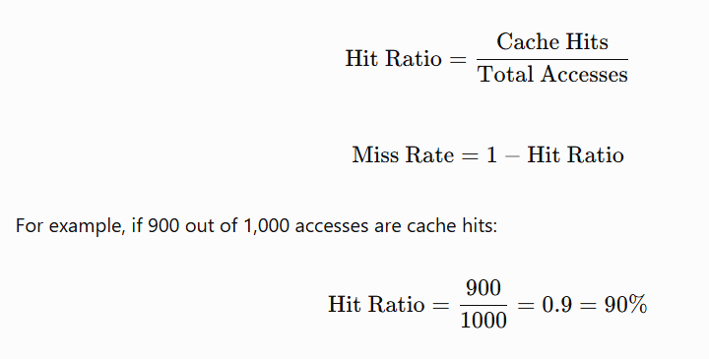

Working of instruction cache
- The CPU requests the next instruction to execute.
- The instruction cache checks whether the required instruction is available.
- If it is available, a cache hit occurs, and the instruction is supplied quickly.
- If it is unavailable, a cache miss occurs, and the instruction must be fetched from a lower cache level or main memory.
- The fetched instruction may be placed in the cache for future use.

Advantages of instruction cache
- Speeds up instruction fetching.
- Reduces instruction-fetch delays.
- Helps keep the CPU execution pipeline supplied with instructions.
- Improves performance in programs with repeated execution paths.

Limitation
When program execution jumps to a new location that is not present in the cache, an instruction-cache miss may occur. This can delay instruction fetching.

Data Cache (D-Cache)

Definition
A data cache is a portion of cache memory used to store copies of data that the CPU frequently or recently reads or writes.
Examples of cached data include variables, array elements, and values used in calculations.

Working of data cache
- The CPU needs a value from memory.
- The data cache checks whether the required data is available.
- On a cache hit, the value is supplied quickly.
- On a cache miss, the required data is obtained from a lower cache level or RAM.
- The data may be stored in cache to speed up future accesses.

Common data-cache write policies
- Write-through: A write updates the cache and also propagates to the next memory level according to the implementation.
- Write-back: A write updates the cache first; the modified data is written to the next memory level later, usually when the cache line is evicted.
Data caches may also use write-allocate or no-write-allocate policies to determine whether a cache line is brought into cache after a write miss.

Advantages of data cache
- Reduces the delay of data reads.
- Helps accelerate repeated calculations.
- Improves the performance of loops and array processing.
- Reduces repeated accesses to main memory.

Limitation
A data-cache miss can delay an operation that depends on the missing value. Frequent misses can significantly reduce performance.

Difference between instruction cache and data cache
Feature | Instruction cache (I-Cache) | Data cache (D-Cache)
Purpose | Stores program instructions | Stores program data
Used during | Instruction fetching | Data reads and writes
Typical contents | Machine instructions | Variables, array elements, values
Main CPU component involved | Instruction-fetch unit | Load/store unit
Typical access pattern | Sequential instruction fetches and branches | Reads, writes, and pointer-based accesses
Common benefit | Faster instruction supply | Faster data access
Cache misses | Delay instruction fetching | Delay data operations

Unified Cache

Definition
A unified cache is a cache that stores both program instructions and data in the same cache structure.
Instead of reserving separate cache storage for instructions and data, a unified cache allows both to share the available capacity.

Working of unified cache
- The CPU generates instruction-fetch and data-access requests.
- Both types of requests are checked against the unified cache.
- If the requested instruction or data is present, it is supplied from the cache.
- If it is absent, the required cache line is obtained from a lower cache level or RAM.
- The shared cache capacity is allocated among instructions and data as needed.

Advantages of unified cache
- Flexible capacity: Instructions and data can share the available cache space.
- Efficient space utilization: Space does not have to be permanently divided into separate instruction and data sections.
- Simplified organization: One shared cache structure can serve both types of access.
- Useful at higher cache levels: Unified L2 and L3 caches can serve instruction and data requests from one or multiple cores.

Disadvantages of unified cache
- Contention: Instruction and data requests compete for shared cache resources.
- Potential conflicts: A workload with heavy data access can displace useful instructions, or vice versa.
- Design complexity: The cache must manage requests from different sources and arbitrate access when necessary.

Cache Mapping Techniques
In modern computer systems, the speed difference between the processor and main memory (RAM) can significantly affect system performance. To bridge this gap, computers use a small, high-speed memory known as cache memory. But since cache is limited in size, the system needs a smart way to decide where to place data from main memory — and that’s where cache mapping comes in.
- Cache mapping is a technique used to determine where a particular block of main memory will be stored in the cache.
- It defines how and where that new data block from main memory will be placed inside the cache.

Key Terminologies in Cache Mapping
Before diving into mapping techniques, let’s understand some important terms:
- Main Memory Blocks: The main memory is divided into equal-sized sections called blocks.
- Cache Lines (or Cache Blocks): The cache memory is also divided into equal partitions called cache lines.
- Block Size: The number of bytes or words stored in one block or line.
- Tag Bits: A small portion of the address used to identify which block of main memory is stored in a particular cache line.
- Number of Cache Lines: Determined by the ratio of Cache Size ÷ Block Size.
- Number of Cache Sets: Determined by Number of Cache Lines ÷ Associativity (used in set-associative mapping).

Types of Cache Mapping
There are three main cache mapping techniques used in computer systems:

Direct Mapping
In Direct mapping, each block of main memory maps to exactly one specific cache line. The main memory address is divided into three parts:
- Tag Bits: Identify which block of memory is stored.
- Line Number: Indicates which cache line it belongs to.
- Byte Offset: Specifies the exact byte within the block.

The formula for finding the cache line is:
Cache Line Number=(Block Number) MOD (Number of Cache Lines)
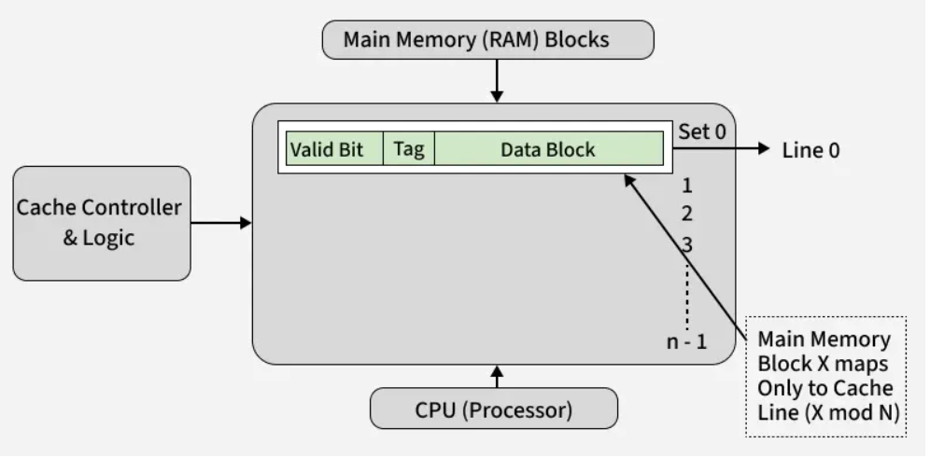

Example
Suppose a cache contains 4 lines and main memory is divided into blocks numbered 0 to 7.
Using the formula:
Cache line=Block number mod 4\text{Cache line}=\text{Block number}\bmod 4Cache line=Block numbermod4
Memory block | Calculation | Cache line
Block 0 | 0 mod 4=0 | Line 0
Block 1 | 1 mod 4=1 | Line 1
Block 2 | 2 mod 4=2 | Line 2
Block 3 | 3 mod 4=3 | Line 3
Block 4 | 4 mod 4=4 | Line 0
Block 5 | 5 mod 4=5 | Line 1
Block 6 | 6 mod 4=6 | Line 2
Block 7 | 7 mod 4=7 | Line 3
Blocks 0 and 4 both map to line 0. Therefore, if block 4 replaces block 0 in that line, block 0 must be fetched again if it is subsequently needed and is no longer available elsewhere in the cache.

Advantages
- Simple and inexpensive hardware.
- Fast cache-line selection.
- Easy to implement.

Disadvantages
- Different memory blocks may compete for the same cache line.
- Conflict misses can be frequent.
- Limited flexibility in placing memory blocks.
Fully Associative Mapping:
In fully associative mapping, a memory block can be placed in any cache line.
Unlike direct mapping, there is no fixed cache line assigned to each memory block.
In fully associative mapping, a memory block can be stored in any line of the cache. The address is divided into:
- Tag Bits: Identify the memory block.
- Byte Offset: Specifies the byte within that block.

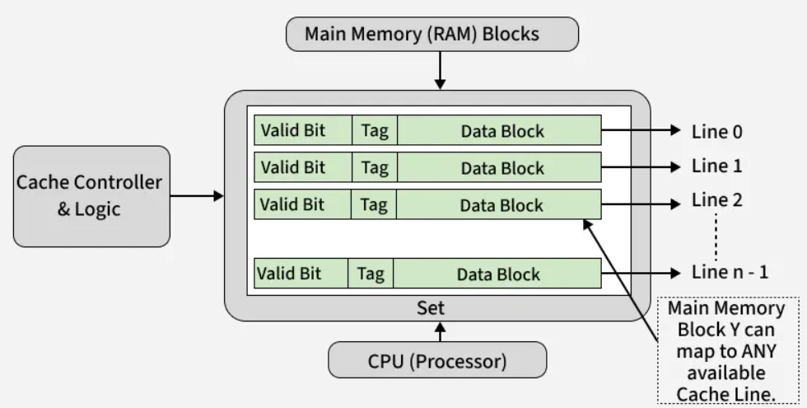
There is no line number here because placement is flexible — any block can go into any cache line.

Advantages
- Maximum placement flexibility.
- Fewer conflict misses than direct mapping for the same cache capacity and block size.
- Useful when memory access patterns are unpredictable.

Disadvantages
- Requires more complex tag-comparison hardware.
- Searching many lines can consume additional power and chip area.
- Replacement logic can be more complicated.

Set-Associative Mapping

Definition
Set-associative mapping combines the advantages of direct and fully associative mapping.
The cache is divided into several sets, and each set contains a fixed number of cache lines called ways. A memory block maps to one particular set but can occupy any way within that set.
For a W-way set-associative cache: 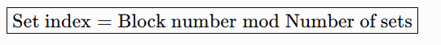
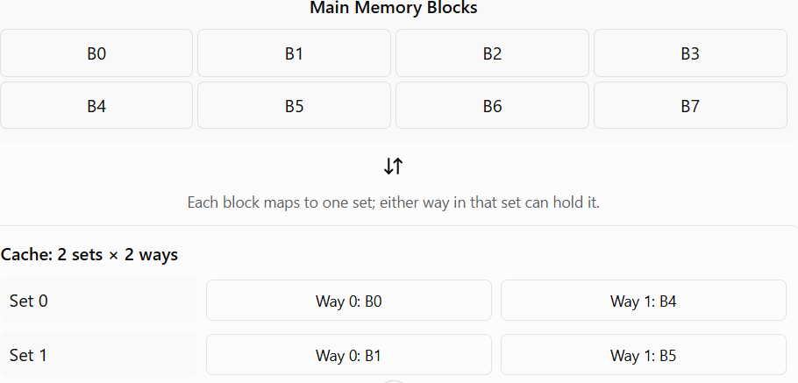

Advantages
- Fewer conflict misses than direct mapping in many workloads.
- Simpler than fully associative mapping.
- Offers a balance between hardware complexity and placement flexibility.

Disadvantages
- More complex than direct mapping.
- Blocks that map to the same set can still compete for space.
- Requires a replacement policy when all ways in a set are occupied.

Comparison of Cache Mapping Techniques
Feature | Direct Mapping | Fully Associative | Set-Associative
Placement | One fixed line | Any line | Any way within one set
Hardware complexity | Low | High | Moderate
Search method | One line selected | Compare tags across all lines | Compare tags within selected set
Conflict misses | More likely | Least restrictive placement | Reduced in many cases
Replacement policy | Not needed to choose a line | Required when full | Required when selected set is full
Cost | Low | High | Moderate
Main benefit | Simplicity | Maximum flexibility | Balance of speed and flexibility

Need for Cache Mapping
Cache mapping is essential for two main reasons:
- Locate Data Efficiently: It helps the processor quickly determine whether the required data is in the cache (cache hit) or must be fetched from main memory (cache miss).
- Manage Data Placement: When a cache miss occurs, mapping tells the system where in the cache to place the new memory block.

Cache Hit and Cache Miss

Cache hit
A cache hit occurs when the requested instruction or data is found in the cache being checked.
For example, if the CPU requests a variable that is already stored in L1 cache, the processor can retrieve it from L1 without fetching that data from RAM.

Cache miss
A cache miss occurs when the requested information is not found in the cache being checked.
The system then checks a lower cache level or retrieves the required information from main memory, depending on the cache hierarchy
Cache Hit | Cache Miss
The required data is found in the cache memory. | The required data is not found in the cache memory.
The CPU accesses data quickly. | The CPU must fetch data from RAM or another lower level of memory.
It takes less time to access data. | It takes more time to access data.
It improves system performance. | It may reduce system performance.
It has a low memory access delay. | It has a higher memory access delay.
Example: The CPU finds the required instruction in the cache. | Example: The CPU searches the cache but must retrieve the instruction from RAM.

Types of cache misses
There are three commonly discussed types, known as the 3C classification.
1. Compulsory miss
This occurs when a memory block is accessed for the first time and has not yet been loaded into the cache.
Example: The CPU accesses a new array element that has never been fetched into cache.
2. Capacity miss
This occurs when the cache cannot hold all the blocks needed by a program during its execution.
Example: A program repeatedly accesses a working dataset much larger than the available cache capacity.
3. Conflict miss
This occurs when multiple memory blocks compete for the same cache line or set, even though other cache locations may be available.
Example: In a direct-mapped cache with four lines, blocks 0 and 4 both map to line 0. Repeatedly alternating between these blocks can cause conflict misses.

Hit ratio and miss rate
The hit ratio measures the fraction of memory accesses that are satisfied by the cache.
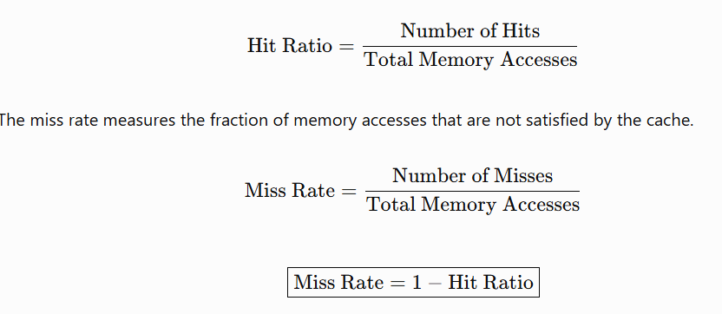
Ex: Suppose a processor makes 2,000 memory accesses. Of these, 1,800 are cache hits and 200 are cache misses.
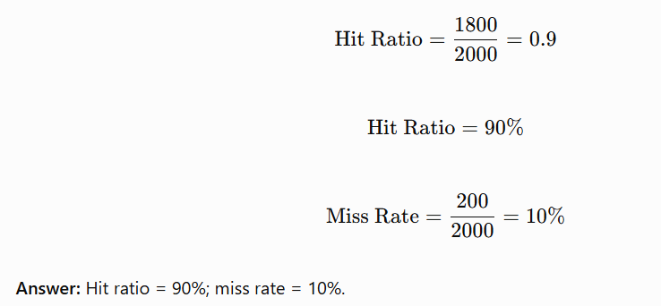

Write-through policy

Definition
In the write-through policy, whenever the CPU writes to a cache line, the updated data is also propagated to the next memory level, such as L2 cache or main memory, according to the cache hierarchy and implementation.
In the simplest model, every cache write updates both the cache and main memory.

Working
- The CPU modifies a value.
- The cache updates the corresponding cache line.
- The updated value is propagated to the next memory level.
- The system maintains consistency between the cache and the memory level being updated, subject to the cache hierarchy.

Advantages
- Main memory or the next memory level receives updates promptly.
- Simpler dirty-data management at the cache level.
- Can simplify recovery and consistency requirements in some designs.

Disadvantages
- Generates more write traffic.
- Can increase memory-bus usage.
- May increase write latency if the CPU must wait for writes to complete.
- Often requires a write buffer to reduce processor stalls.

Write-back policy

Definition
In the write-back policy, the CPU updates the cache first. The modified data is written to the next memory level later, usually when the cache line is evicted or explicitly flushed.
A cache line that has been modified but not yet written back is marked using a dirty bit.

Working
- The CPU modifies data in the cache.
- The cache line is marked dirty.
- The next memory level may continue to contain the older value.
- When the dirty line is evicted or flushed, the modified data is written back.
- The dirty bit is cleared after the write-back completes successfully.

Example
Initially, x = 10 in both cache and RAM.
The CPU executes:

Example
Initially, x = 10 in both cache and RAM.
The CPU executes:

Example
Initially, x = 10 in both cache and RAM.
The CPU executes:
x = 20;
Under a write-back policy:
- Cache value becomes 20.
- The cache line is marked dirty.
- RAM may still contain 10.
- When the dirty cache line is written back, RAM is updated to 20.
The data is not necessarily written to RAM immediately after the CPU changes it.

Advantages
- Reduces repeated writes to lower memory levels.
- Reduces memory-bus traffic for repeated updates to the same cache line.
- Can improve performance for write-intensive workloads.
- Often uses memory bandwidth more efficiently.

Disadvantages
- Requires dirty-bit tracking.
- Evicting a dirty line requires a write-back operation.
- Cache-coherence and consistency mechanisms become more involved.
- A dirty cache line must be preserved or written back correctly during eviction and system transitions.

Write-through versus write-back
Feature | Write-through | Write-back
Cache update | Immediate | Immediate
Next memory-level update | Propagated on each write under the basic model | Usually delayed until eviction or flush
Dirty bit | Generally not needed for tracking delayed writes | Needed to identify modified lines
Write traffic | Usually higher | Usually lower
Write performance | Can be slower without buffering | Often faster for repeated writes
Complexity | Simpler dirty-data handling | More complex management
Main advantage | Prompt propagation of writes | Reduced lower-level write traffic
Main disadvantage | More write traffic | Dirty data must be tracked and preserved
Cache Performance:
A cache memory is built using two main component arrays: the tag array and the data array.

Tag array
The tag array stores the identifying information for the memory block present in each cache line.
It commonly contains:
- Tag bits: Identify which main-memory block is stored.
- Valid bit: Indicates whether the cache line contains valid data.
- Dirty bit: Indicates whether the cache line has been modified, in a write-back cache.
- Replacement information: May be maintained to help select a line for replacement.

Data array
The data array stores the actual instructions or data fetched from main memory. Each cache line contains a block of data.

Address division
A memory address is commonly divided into three fields:
Field | Purpose
Tag | Identifies the memory block
Index / Set index | Selects a cache line or set
Block offset | Selects a byte or word within a block
For a byte-addressable cache:
Address=Tag+Index+Offset

Tag Array | Data Array
Stores tag bits and associated status bits. | Stores actual data or instructions.
Identifies the memory block in a cache line. | Holds the contents of the memory block.
Used to check cache hits and misses. | Supplies the requested data on a hit.
Requires relatively little storage. | Usually requires much more storage.

Types of Cache Misses
1. Compulsory Miss (Cold-start miss)
Occurs when a block is accessed for the first time and has never been loaded into the cache.
Example: The CPU accesses a new memory location for the first time.
Solution: Prefetching may reduce the delay in some cases.

2. Capacity Miss
Occurs when the cache is too small to hold all the blocks needed by the program.
Example: A program repeatedly accesses a working set larger than the cache capacity.
Solution: Increase cache capacity or improve data locality.

3. Conflict Miss
Occurs when multiple memory blocks compete for the same cache line or set, even though other cache locations may be available.
Example: Two frequently used blocks map to the same line in a direct-mapped cache.
Solution: Increase associativity or use a different cache organization.

Multi-Level Caches
Modern processors use multiple cache levels to balance speed, capacity, and cost.

Levels of cache
- L1 cache: Closest to the CPU core, very fast, and usually small. It is often divided into instruction cache (L1I) and data cache (L1D).
- L2 cache: Larger than L1 but slower. It may be private to a core.
- L3 cache: Generally larger and slower than L2 and often shared among multiple cores.
- Main memory: Stores much more data but has a higher access latency than cache.

How multi-level caching works
- The CPU first checks L1.
- If L1 misses, it checks L2.
- If L2 misses, it checks L3, if present.
- If all cache levels miss, data is fetched from RAM and supplied to the processor.

Advantages
- Reduces average memory access time.
- Bridges the speed gap between the CPU and RAM.
- Provides a balance between performance, capacity, and hardware cost.

Cache Replacement Policies — LRU
A replacement policy determines which cache block should be removed when a new block must be loaded into a full cache set.
Common policies include:
- LRU (Least Recently Used)
- FIFO (First In, First Out)
- Random replacement
- LFU (Least Frequently Used)

Why Are Cache Replacement Policies Needed?
- Cache memory has limited storage capacity.
- New data may need to be loaded when the cache is already full.
- The system must decide which existing block to remove.
- A good replacement policy helps reduce cache misses and improve performance.
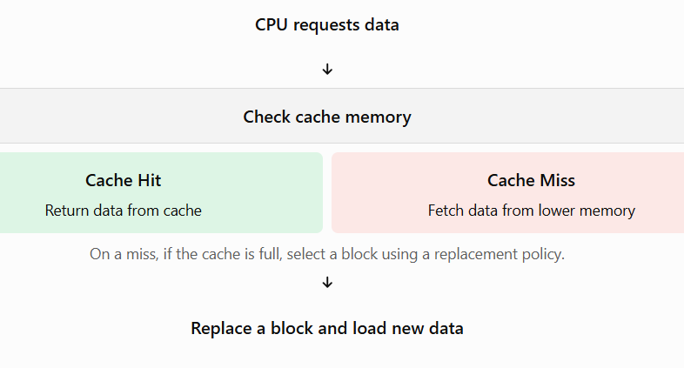

LRU — Least Recently Used
LRU replaces the block that has not been accessed for the longest time. It is based on the principle of temporal locality: recently accessed data is likely to be accessed again soon.

Example of LRU
Suppose a cache can hold three blocks: A, B, and C.
Step | Access | Cache contents (LRU → MRU) | Result
1 | A | A | Miss
2 | B | A, B | Miss
3 | C | A, B, C | Miss
4 | A | B, C, A | Hit
5 | D | C, A, D | Miss; B replaced
LRU = least recently used, and MRU = most recently used.
At step 5, block B is replaced because it is the least recently accessed block.

Advantages of LRU
- Uses recent access history to make replacement decisions.
- Often performs well when programs exhibit temporal locality.
- Is deterministic for a given access sequence and initial cache state.

Disadvantages of LRU
- Tracking access order requires extra hardware or bookkeeping.
- Exact LRU becomes expensive for highly associative caches.
- It may perform poorly for some access patterns, such as repeatedly scanning a large sequence of blocks.

